Tracy Krumm
Tracy Krumm has been a professional studio artist, educator and arts administrator for over 30 years. Her current work is an ongoing investigation of constructed forms and structures that reference identity, duality, gender and labor.

She currently serves as Director for Artistic Advancement at the Textile Center in Minneapolis and maintains a studio practice in St. Paul, Minnesota.

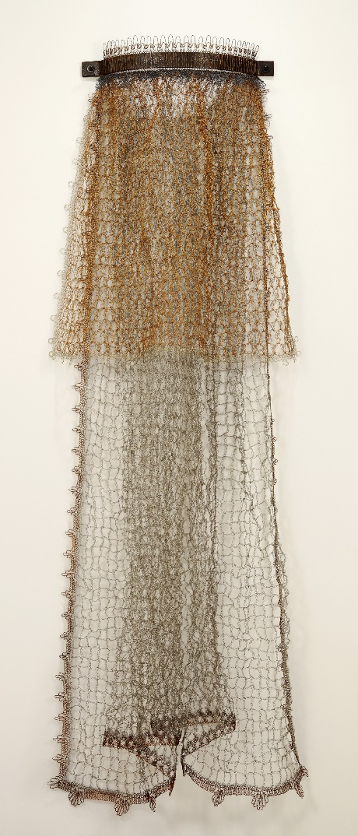
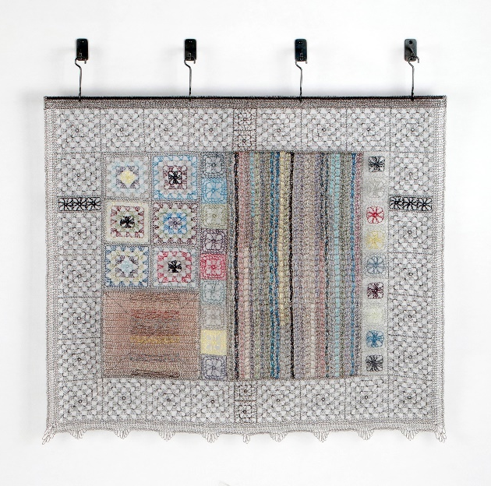
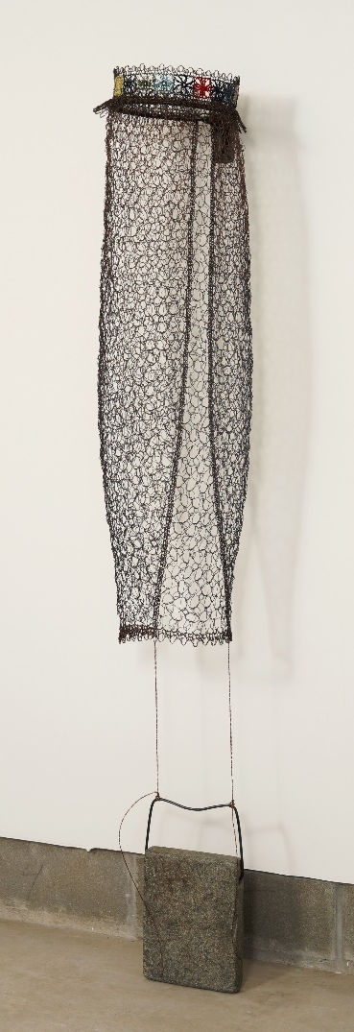

Portrait (aproned), by Tracy Krumm

Plotted TK90, by Tracy Krumm

Portrait (armored) – angle, by Tracy Krumm

