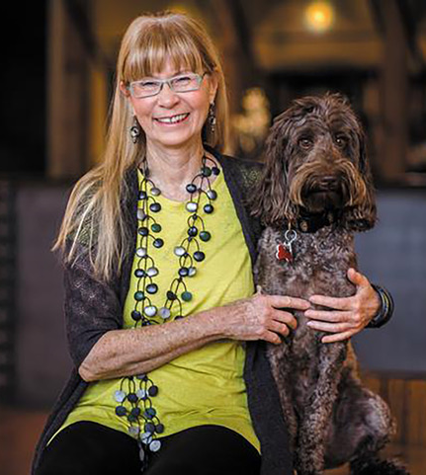
Sherry Leedy
Sherry Leedy Contemporary Art was established in 1985, and as the first and longest running contemporary art gallery in the Crossroads Arts District of Kansas City, Sherry Leedy Contemporary Art was instrumental in the creation and revitalization of this district. Leedy has curated hundreds of solo and group exhibitions that have set a standard of excellence. In 1996, Leedy co-curated Pure Vision: American Bead Artists with B.J. Shigaki, former Director of the Rochester Arts Center, MN for Exhibits USA. Pure Vision toured museums throughout the United States from 1997-2000.

In addition to her work as a gallerist, Leedy is a practicing artist with work represented in the permanent collections of the Los Angeles County Museum, Los Angeles, CA; Nerman Museum for Contemporary Art, Overland Park, KS; and Daum Museum of Contemporary Art, Sedalia, MO among others.

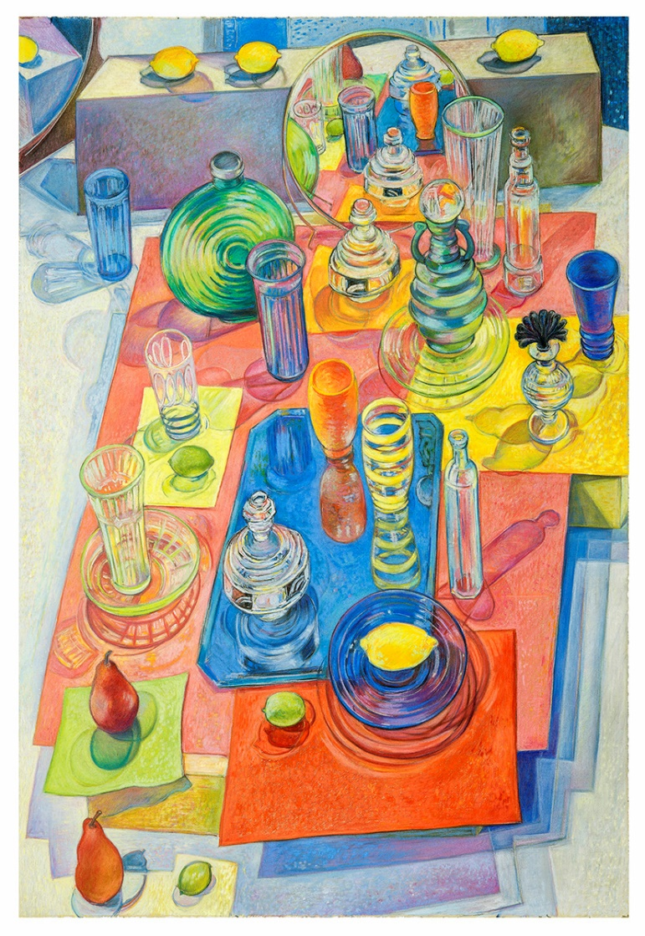

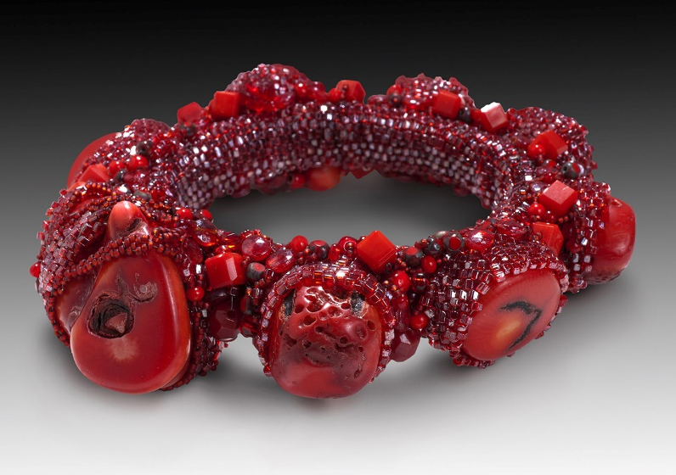
Oppenheimer Bracelet, beadwork by Sherry Leedy

Collection of the Nerman Museum of Contemporary Art.

Photo credit: EG Schempf

Hopscotch, 41” x 30” pastel drawing by Sherry Leedy

Collection of the Daum Museum of Contemporary Art.

Photo credit: EG Schempf

