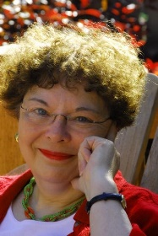
Diane Fitzgerald
Diane Fitzgerald is a beader who has authored more than 150 magazine articles, a dozen books and numerous tutorials. She has taught nationally and internationally and collects American art glass beads and 20th century glass jewelry.

Diane is a graduate of the University of Minnesota School of Journalism, BA, MA; and has a minor in Design, also from the U of M.

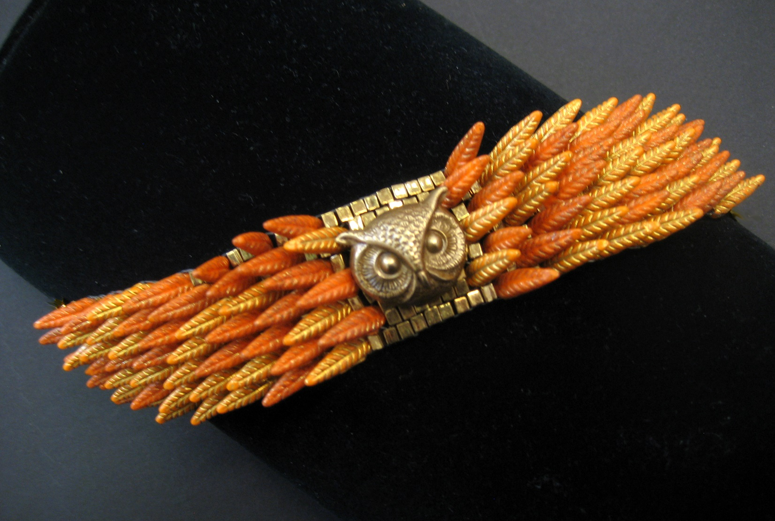

Owl Bracelet, by Diane Fitzgerald
Photo credit: Athena Cuff

