Press Release-Whoooo’ll Bead for Owls

From: The Upper Midwest Bead Society and the International Owl Center

Subject: Press Release for Whoooo’ll Bead for Owls Beaded Owl Competition

What is “Whoooo’ll Bead for Owls”? It’s a beading contest being held to benefit the Upper Midwest Bead Society and the International Owl Center (Houston, MN) and give bead artists the opportunity to apply to have their owl-themed pieces accepted into a juried show.

Contact: Margo Yee, dsimargoyee@hotmail.com, or text 505-301-3970 if you’d like more photos or information.

Two great organizations are joining forces to host a “Whoooo’ll Bead for Owls” juried beading competition. This competition benefits both the Upper Midwest Bead Society and the International Owl Center and helps celebrate International Owl Awareness Day. 31 pieces from 8 states and one from Italy were entered and are now being juried.
The jurors are: Diane Fitzgerald, the founder of UMBS who has authored several books and articles about beading; Judy Onofrio, a well-known mixed media artist from Rochester, Sherry Leedy of the Sherry Leedy Gallery in Kansas City; Barbara Rogers, Art Professor Emeritus University of Arizona from Tucson; Tracy Krumm, Director for Artistic Advancement at the Textile Center and McKnight Visual Artist Fellow, and Karla Bloem, Executive Director of the International Owl Center.

Cash prizes of $1000, $750, $500 and $250 will be awarded by the jury for winning pieces.

The beadwork will be on display at the International Owl Center in Houston, MN from August 1-15, 2020 as well as online. If the Center is not able to be open by then the show will just run in the online format. The plan is to announce on July 12, 2020 on the “Whoooo"ll Bead for Owls-beading contest” Facebook page if there will be a physical show.

Much of this special beadwork will be available for purchase August 1-15, 2020 online at www.internationalowlcenter.org. Buying a piece will benefit the bead artist and both of the non-profit organizations.

The 30-year-old Upper Midwest Bead Society (www.umbs.org), based out of the Twin Cities, has over 100 members (including members from the Twin Cities and Rochester) who have been involved in organizing the competition.

The International Owl Center will use its share of the proceeds toward its future building plans in Trailhead Park. Becky Pancake, President of Upper Midwest Bead Society, said the Bead Society will use the funds for a special workshop.

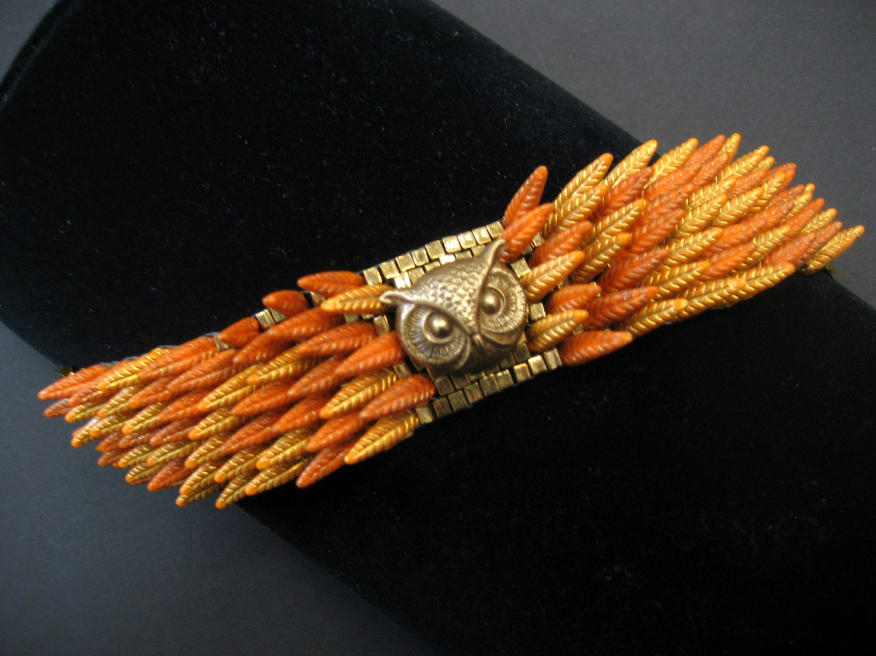
Owl Bracelet by Diane Fitzgerald, Founder Upper Midwest Bead Society

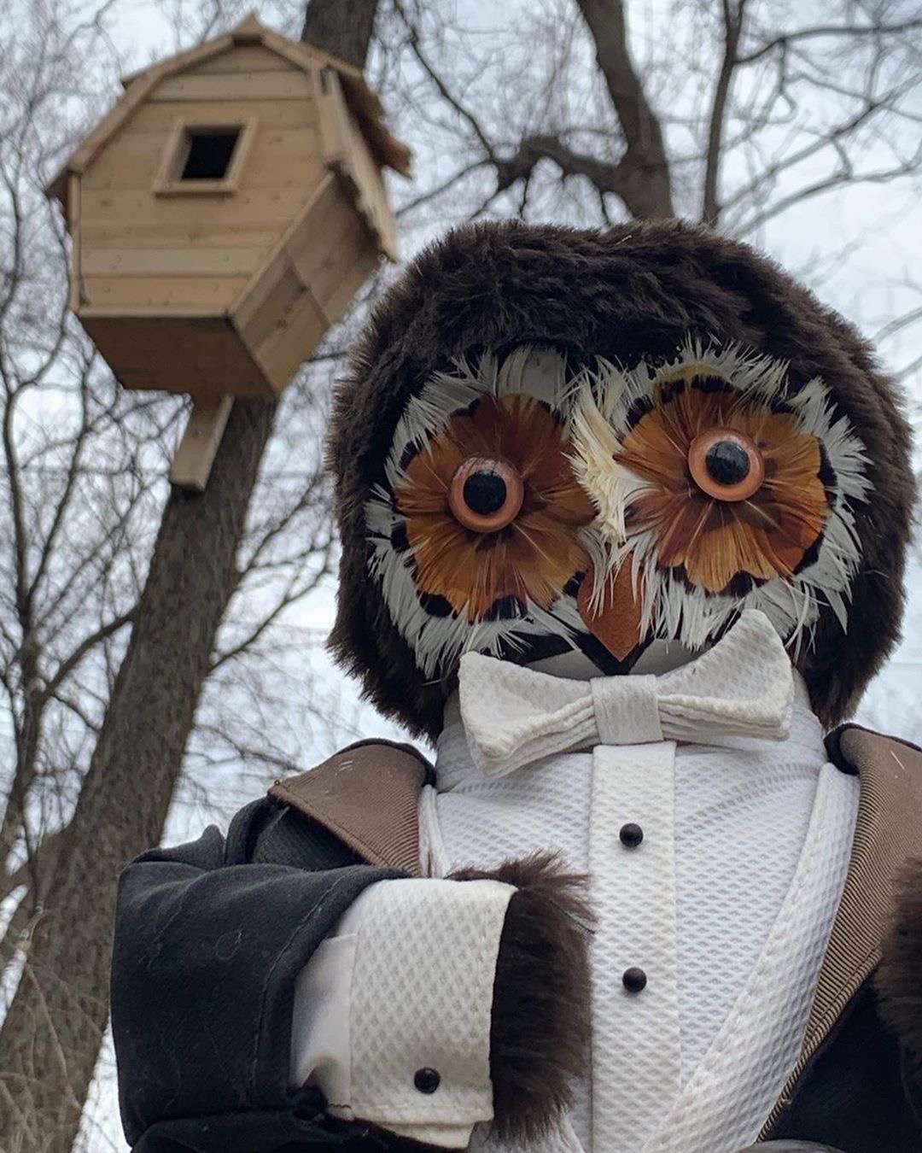

Owl House by Judy Onofrio

