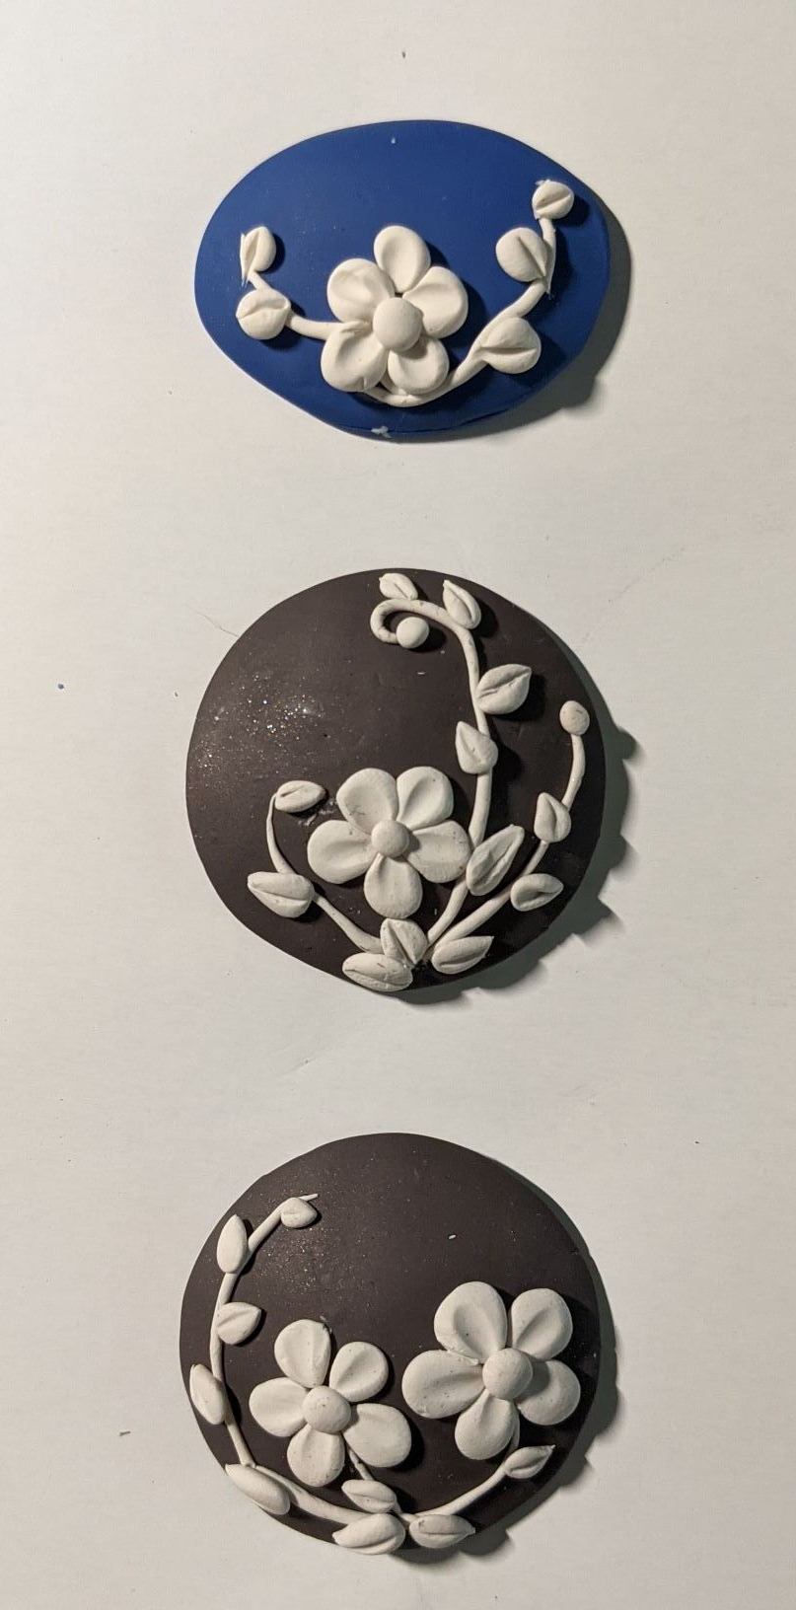
Cameos made from Polymer Clay with Roberta Sorenson
Technique - hand manipulating Polymer Clay
August 3rd 3-4:30pm
Format: Zoom class
Skill Level: No experience necessary
Class prerequisites: get supplies
Teacher fee: non
Class limit: 15 students
No kits available

Materials needed: 2 colors of polymer clay.
I used a brownish black and very pale beige Premo brand.

Tools needed:a clay roller is very helpful, but you could use a straight-sided glass vase or even an unopened pop can
Work surface such as a 6X6 or 12X12 glazed ceramic tile
Clay blade, not necessary but very helpful
Cookie cutter
Toothpick
Small paintbrush with a rounded handle tip or a small clay-shaper
Small piece of aluminum foil
Toaster oven or home oven, with well-regulated temperature

