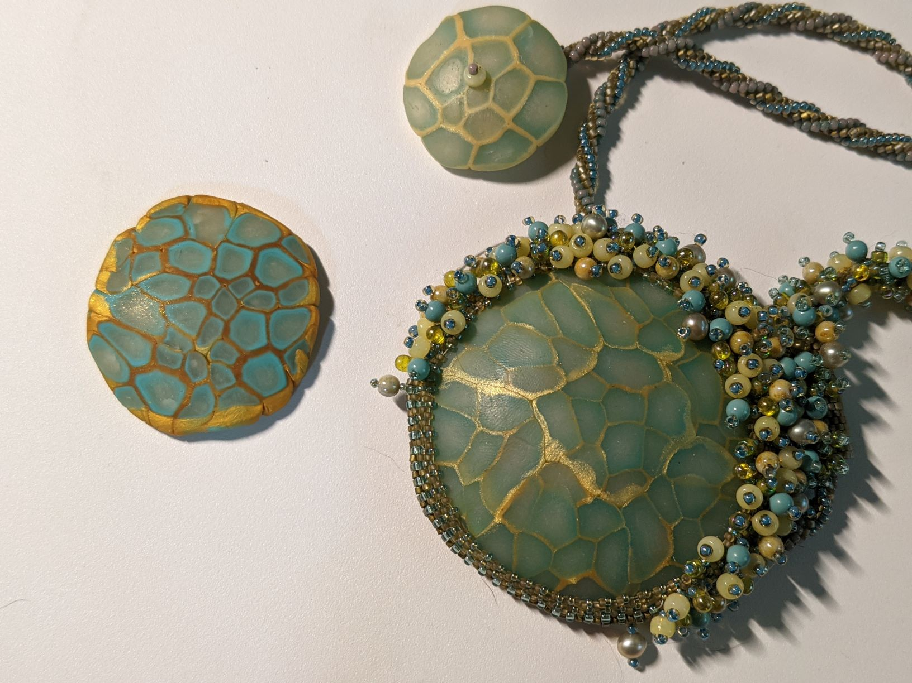
Cabochon Made With a Simple Polymer Clay Cane
Teacher: Roberta Sorenson
August 17th 3-4:30pm
Format: Zoom class
Skill Level: No experience necessary
Class prerequisites: get supplies
Teacher fee: non
Class limit: 15 students
No kits available

Materials used: Premo clay in Translucent, 18K Gold, and Blue Pearl

Tools:Work surface, such as a glazed 12X12 tile. Can be bought for about $2 at Home Depot or Menards.
Clay roller. You can use a straight-sided glass vase or an unopened pop can.
Pasta machine is very helpful, but not necessary as long as you have a roller.
Clay blade
Small piece of aluminum foil.
Oven-can be a toaster oven or your home oven, but needs to keep stable temperatures.

