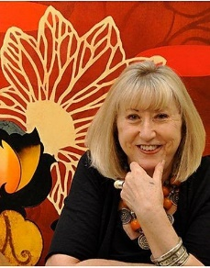
Barbara Rogers
Barbara Rogers is Professor Emeritus of Painting and Drawing in The School of Art at The University of Arizona in Tucson, AZ.

Since 1968, Rogers' work has been presented in more than 43 solo exhibitions.

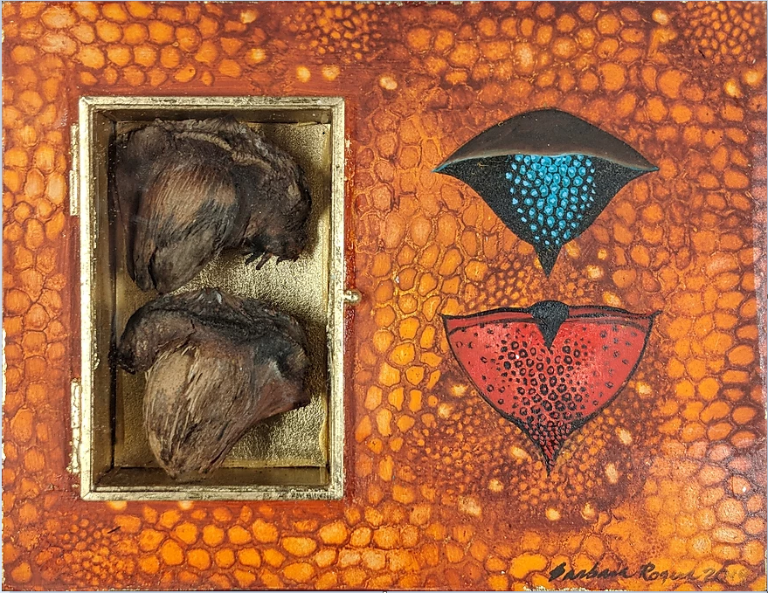
Shrines to Botanical Relics #1, 8” x 10”
by Barbara Rogers

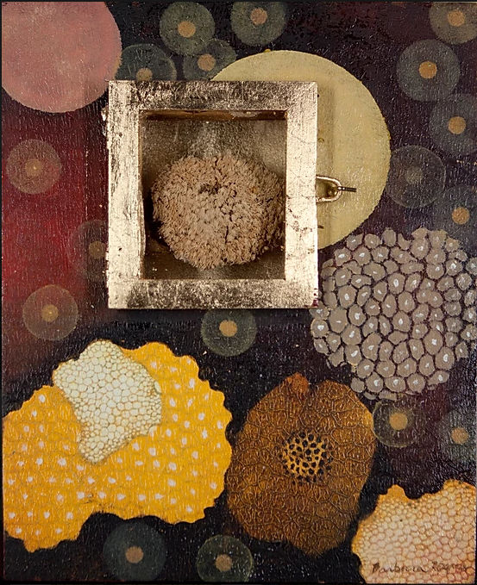
Shrines to Botanical Relics #3, 10” x 8”
by Barbara Rogers
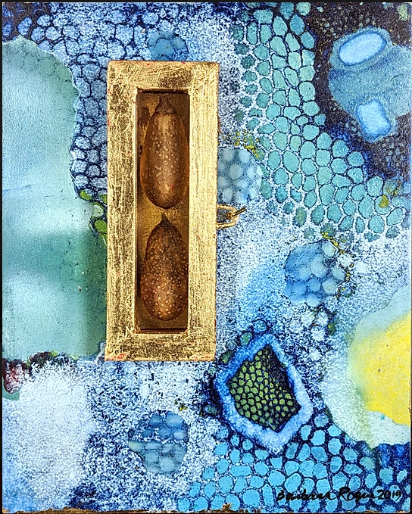
Shrines to Botanical Relics #5, 10” x 8”
by Barbara Rogers

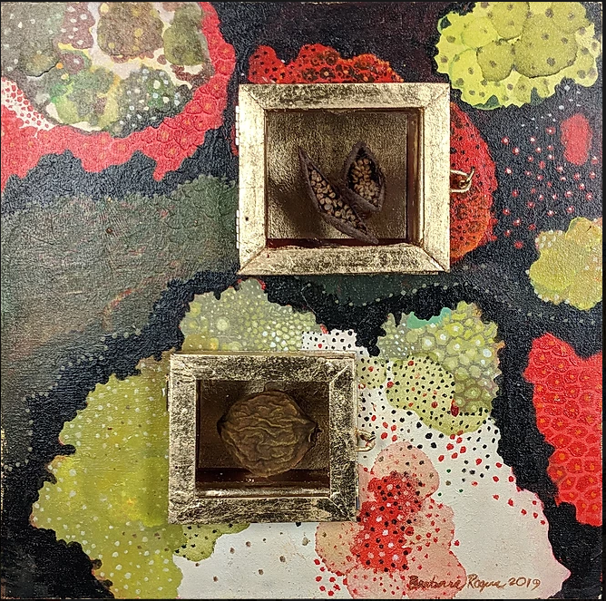
Shrines to Botanical Relics #6, 12” x 12”
by Barbara Rogers

