Press Release-Whoooo’ll Bead for Owls

From: The Upper Midwest Bead Society and the International Owl Center

Subject: Press Release for Whoooo’ll Bead for Owls Beaded Owl Competition

What is “Whoooo’ll Bead for Owls”? It’s a beading contest being held to benefit the Upper Midwest Bead Society and the International Owl Center (Houston, MN) and give bead artists the opportunity to apply to have their owl-themed pieces accepted into a juried show.

Contact: Margo Yee, dsimargoyee@hotmail.com, or text 505-301-3970 if you’d like more photos or information.

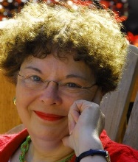
Diane Fitzgerald
Diane Fitzgerald is a beader who has authored more than 150 magazine articles, a dozen books and numerous tutorials. She has taught nationally and internationally and collects American art glass beads and 20th century glass jewelry.

Diane is a graduate of the University of Minnesota School of Journalism, BA, MA; and has a minor in Design, also from the U of M.

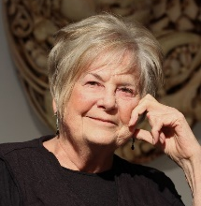
Judy Onofrio
Judy Onofrio, A multi-media sculptor, has been creating art for over five decades. Her work demonstrates her lifelong interest in form and materiality. Her work is in found in the collections of The Museum of Fine Arts, Houston, TX: Renwick Gallery, The Smithsonian American Art Museum, Washington, DC; The Museum of Arts and Design, New York, NY; The Minneapolis Institute of Arts and Frederick R. Weisman Museum, Minneapolis, MN and over 40 other museum and public collections.

Onofrio was awarded Minnesota Crafts Council Lifetime Achievement Award; She is a recipient of the Rochester Art Center Lifetime Achievement Award; The McKnight Foundation Distinguished Minnesota Artist Award in recognition of her ongoing contribution as an artist and educator. In 2020, she was awarded the Woman’s Caucus for the Arts Lifetime Achievement Award.

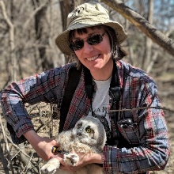
Karla Bloem
Karla Bloem is the Executive Director of the International Owl Center and has been educating people about owls for 22 years. She is also the leading authority on Great Horned Owl vocalizations and presents her work at international conferences.
photo © Chris Sargent

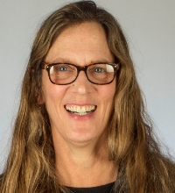
Tracy Krumm
Tracy Krumm has been a professional studio artist, educator and arts administrator for over 30 years. Her current work is an ongoing investigation of constructed forms and structures that reference identity, duality, gender and labor.

She currently serves as Director for Artistic Advancement at the Textile Center in Minneapolis and maintains a studio practice in St. Paul, Minnesota.

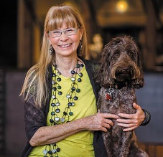
Sherry Leedy
Sherry Leedy Contemporary Art was established in 1985, and as the first and longest running contemporary art gallery in the Crossroads Arts District of Kansas City, Sherry Leedy Contemporary Art was instrumental in the creation and revitalization of this district. Leedy has curated hundreds of solo and group exhibitions that have set a standard of excellence. In 1996, Leedy co-curated Pure Vision: American Bead Artists with B.J. Shigaki, former Director of the Rochester Arts Center, MN for Exhibits USA. Pure Vision toured museums throughout the United States from 1997-2000.

In addition to her work as a gallerist, Leedy is a practicing artist with work represented in the permanent collections of the Los Angeles County Museum, Los Angeles, CA; Nerman Museum for Contemporary Art, Overland Park, KS; and Daum Museum of Contemporary Art, Sedalia, MO among others

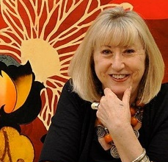
Barbara Rogers
Barbara Rogers is Professor Emeritus of Painting and Drawing in The School of Art at The University of Arizona in Tucson, AZ. Since 1968, Rogers' work has been presented in at least 43 solo exhibitions.

