Karla Bloem

Karla Bloem is the Executive Director of the International Owl Center and has been educating people about owls for 22 years. She is also the leading authority on Great Horned Owl vocalizations and presents her work at international conferences.

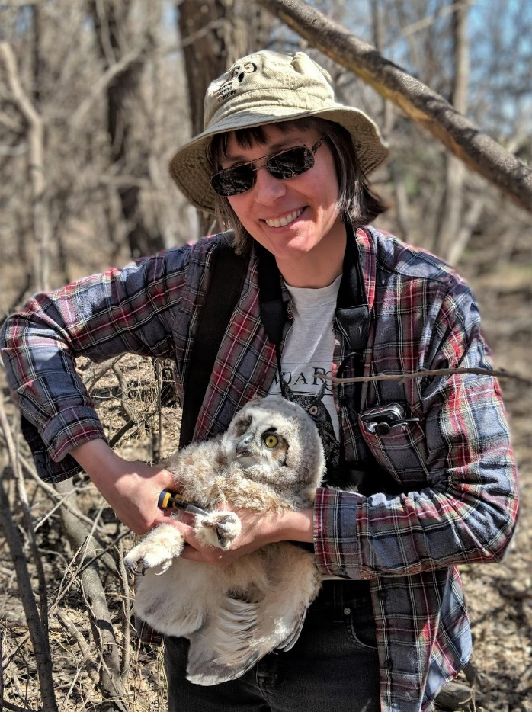
Karla banding an owlet.
Photo credit: Chris Sargent ©

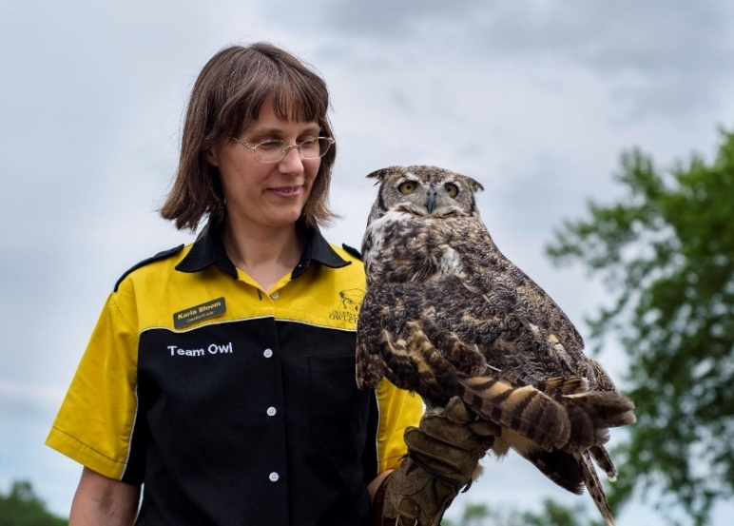
Karla Bloem with Alice, a great horned owl.
Photo credit: Brian Plath ©

