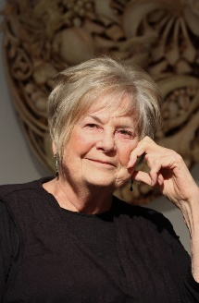
Judy Onofrio
Judy Onofrio, A multi-media sculptor, has been creating art for over five decades. Her work demonstrates her lifelong interest in form and materiality. Her work is in found in the collections of The Museum of Fine Arts, Houston, TX: Renwick Gallery, The Smithsonian American Art Museum, Washington, DC; The Museum of Arts and Design, New York, NY; The Minneapolis Institute of Arts and Frederick R. Weisman Museum, Minneapolis, MN and over 40 other museum and public collections.

Onofrio was awarded Minnesota Crafts Council Lifetime Achievement Award; She is a recipient of the Rochester Art Center Lifetime Achievement Award; The McKnight Foundation Distinguished Minnesota Artist Award in recognition of her ongoing contribution as an artist and educator. In 2020, she was awarded the Woman’s Caucus for the Arts Lifetime Achievement Award.

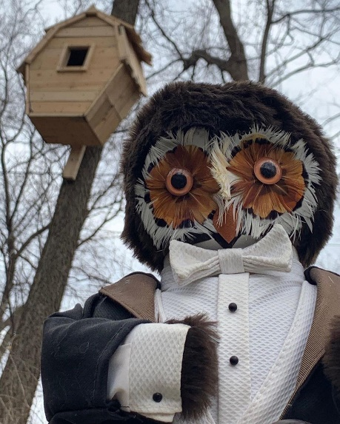
Owl House, by Judy Onofrio

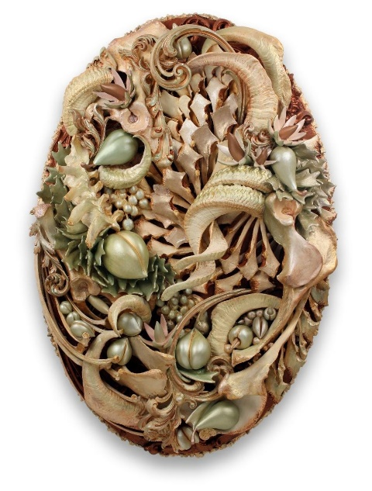
Abundance, by Judy Onofrio

50”h x 30” w X 13”D)
Bone, Horn, Wood carved fruit, cast syrocco, acrylic paint

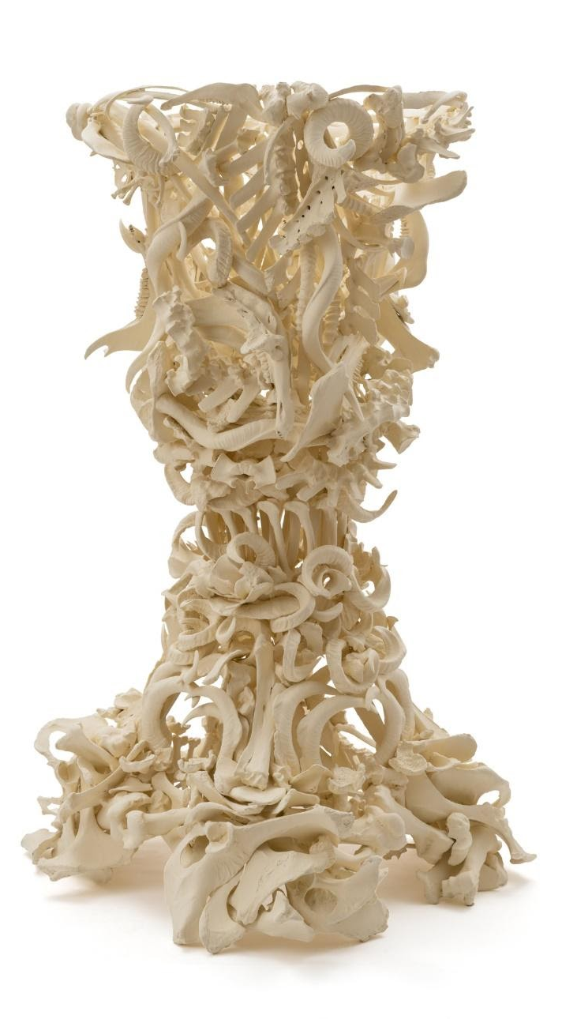
Chalice, by Judy Onofrio
83"h x 51"w x 53”d

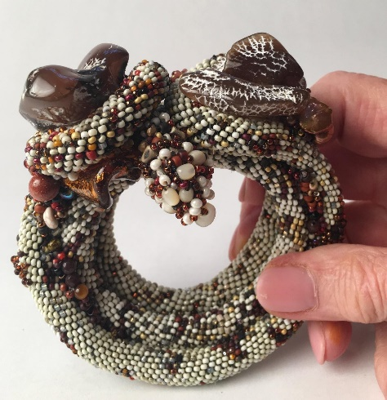
Judy Onofrio bracelet done in a variation of peyote stitch with snake skin agate and variety of beads

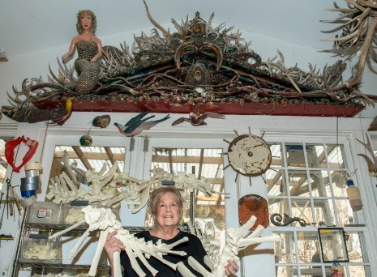
Judy Onofrio
Photo by Ted Degener

